Example No 01

Input:

using System;

namespace Abdullah_Sadiq_CP_Lab_04

{

class Program

{

static void Main(string[] args)

{

int a = 5, b = 4;

Console.WriteLine("The value of a+b is\t:{0}", a + b);

Console.WriteLine("The value of a+(b++) is\t:{0}", a + (b++));

Console.WriteLine("The value of a+b is\t:{0}", a + b);

Console.WriteLine("The value of a+(++b) is\t:{0}", a + (++b));

Console.WriteLine("The value of a+b is\t:{0}", a + b);

Console.WriteLine("The value of 14/a is\t:{0}", 14 / a);

Console.WriteLine("The value of 14%a is\t:{0}", 14 % a);

}

}

}

Output:

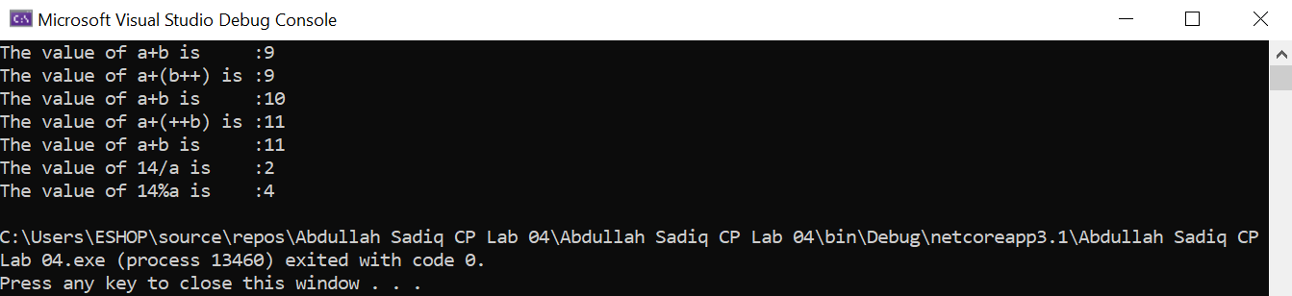

Example No 02

Input:

using System;

namespace Abdullah_Sadiq_CP_Lab_04

{

class Program

{

static void Main(string[] args)

{

bool a = true;

bool b = false;

Console.WriteLine(a && b);

Console.WriteLine(a || b);

Console.WriteLine(!b);

Console.WriteLine(b || true);

Console.WriteLine((5 > 7) ^ (a == b));

}

}

}

Output:

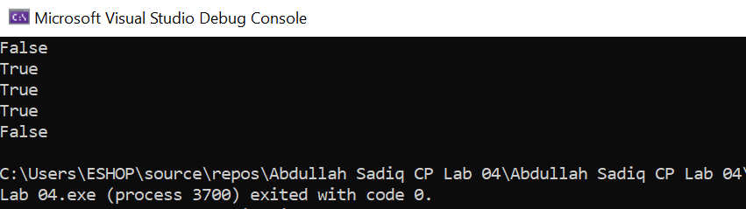

Example No 03

Input:

using System;

namespace Abdullah_Sadiq_CP_Lab_04

{

class Program

{

static void Main(string[] args)

{

int x = 10, y = 5;

Console.WriteLine("x>y:\t" + (x > y));

Console.WriteLine("x<y:\t" + (x < y));

Console.WriteLine("x>=y:\t" + (x >= y));

Console.WriteLine("x<=y:\t" + (x <= y));

Console.WriteLine("x==y:\t" + (x == y));

Console.WriteLine("x!=y:\t" + (x != y));

}

}

}

Output:

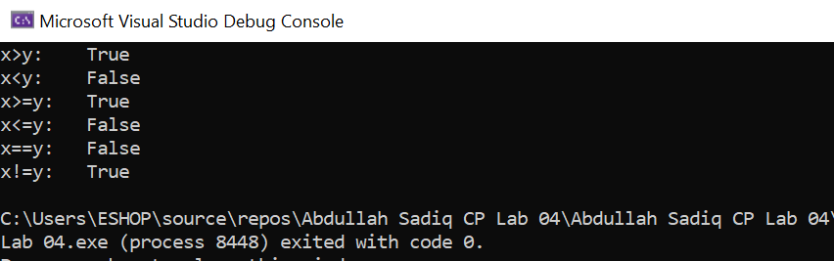

Task No 01: Which of the following values can be assigned to variables of type float, double and decimal:

**5, -5.01, 34.567839023, 12.345, 8923.1234857, 3456.091124875956542151256683467**

Solution:

1. 5 = float
2. -5.01 = float
3. 34.567839023 = double
4. 12.345 = float
5. 8923.1234857 = double
6. 3456.091124875956542151256683467 = decimal

Task No 02: Create a simple calculator which will perform all arithmetical, Bit wise operation and logical operation on two number.

Input:

int num1 = 123, num2 = 456;

Console.WriteLine("\tArithmatical Operators\n");

Console.WriteLine(" -Addition-");

Console.WriteLine("Sum of {0} and {1} is {2}", num1, num2, num1 + num2);

Console.WriteLine("\n -Subtraction-");

Console.WriteLine("Difference of {0} and {1} is {2}", num1, num2, num2 - num1);

Console.WriteLine("\n -Multiplication-");

Console.WriteLine("Product of {0} and {1} is {2}", num1, num2, num1 * num2);

Console.WriteLine("\n -Division-");

Console.WriteLine("Quotient of {0} and {1} is {2}", num1, num2, num2 / num1);

Console.WriteLine("\n -Module-");

Console.WriteLine("Modulus of {0} and {1} is {2}", num1, num2, num2 % num1);

Console.WriteLine("\n\n\tBit Wise Operators\n");

Console.WriteLine(" -And Operator-");

Console.WriteLine("Bit Wise AND Operator of {0} and {1} is {2}", num1, num2, num1 & num2);

Console.WriteLine("\n -OR Operator-");

Console.WriteLine("Bit Wise OR Operator of {0} and {1} is {2}", num1, num2, num1 | num2);

Console.WriteLine("\n -XOR Operator-");

Console.WriteLine("Bit Wise XOR Operator of {0} and {1} is {2}", num1, num2, num1 ^ num2);

Console.WriteLine("\n\n\tLogical Operator");

bool output;

//Or operator

output = (num1 == num2) || (num1 > 120);

Console.WriteLine(output);

output = (num1 == num2) && (num1 > 120);

Console.WriteLine(output);

Output:

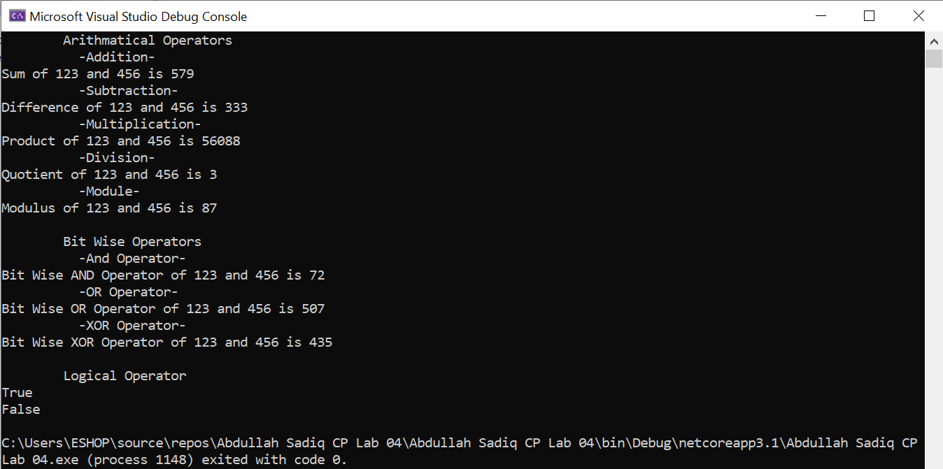

Task No 03: Create a simple program to calculate Hypotenuse using Pythagoras theorem c^2 =(a^2 + b^2)

Input:

using System;

namespace Abdullah_Sadiq_CP_Home_Tasks

{

class Program

{

static void Main(string[] args)

{

double hyp, side_a, side_b;

Console.WriteLine("\t-Calculate the Hypotanuse of a Right Angle Triangle-");

Console.WriteLine("\nEnter Lenght of Side 'A' (in cm):");

side_a = Convert.ToDouble(Console.ReadLine());

Console.WriteLine("Enter Lenght of Side 'B' (in cm):");

side_b = Convert.ToDouble(Console.ReadLine());

hyp = side_a*side_a + side_b*side_b;

double final_answer = Math.Sqrt(hyp);

Console.WriteLine("The Length of Hypotanuse is {0} cm", final_answer);

}

}

}

Output:

